1. **Tidal Wave Simulation with Different Height of Wave**

Assume that length of wave is $10,$ initial condition for position is $1$, and height of wave is $1$.

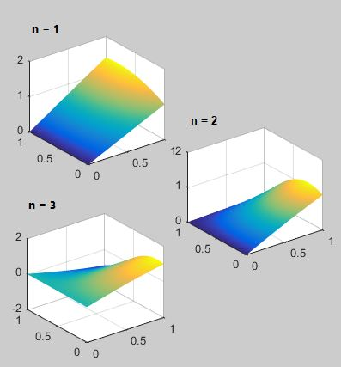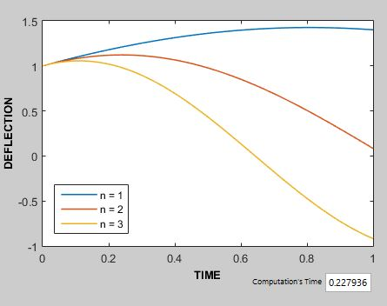

*Figure 11. Tidal Wave Simulation with Height of Wave $1$*

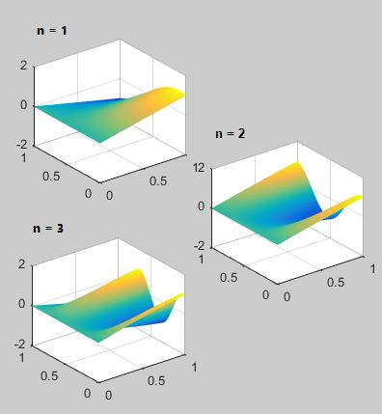

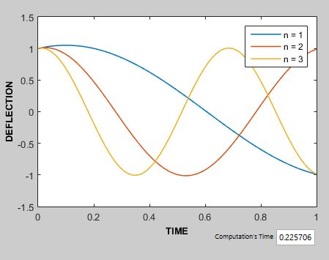

*Figure 12. Tidal Wave Simulation with Height of Wave is $10$*

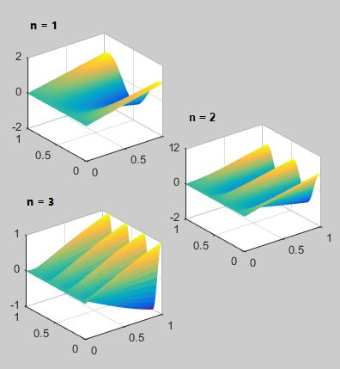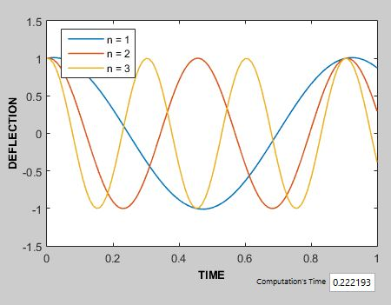

*Figure 10. Tidal Wave Simulation with Height of Wave is $50$*